5 Tips For Keeping Your Children Connected To Nature This Fall
By Andres Marten

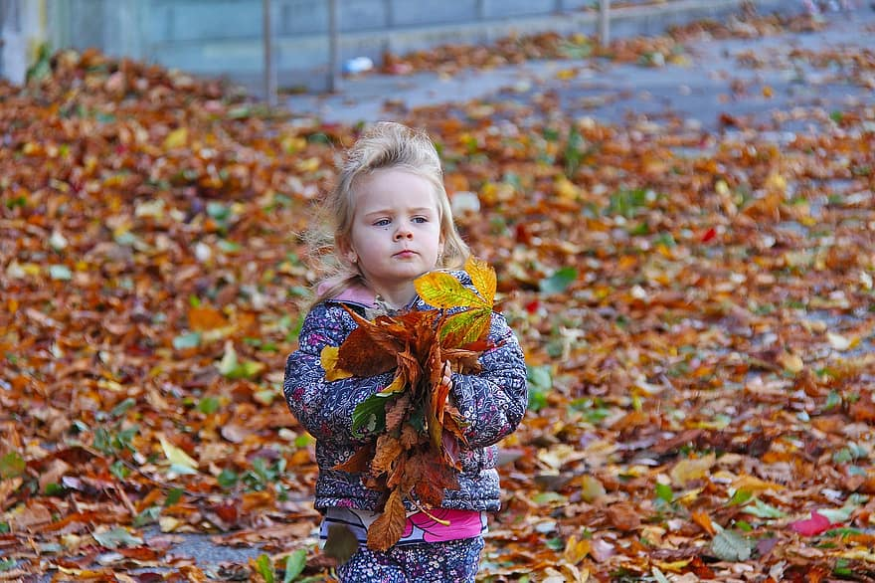
Source

Cabin fever, made more intense this year because of the pandemic, seems to be affecting children worse than adults. But the cure for feeling cooped up is simple. Get outside!
There’s nothing like the colors of autumn to get you ready for cooler weather ahead, especially in Ohio. Keeping children connected to nature instead of the internet is easy when you live in the Buckeye State.
Kids love hands-on activities, so enjoy these experiences with your little ones:

1. Backyard Wildlife
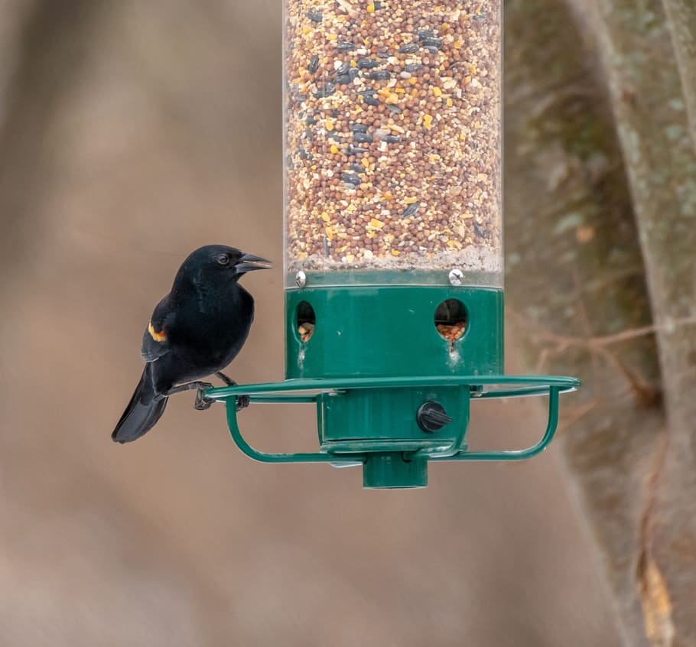
Source
With squirrels scurrying about to gather up nuts and chipmunks getting ready for a long nap, your backyard continues to be a home for birds and wildlife.
Set up a few birdhouses and feeders and stock up on winter wild birdseed. Feed the regulars and those visitors that are flying south for the winter.
Hands-on activity: Make a list of all the types of birds you see, create a folder and show the kids how to draw pictures of their favorites.

2. Indoor Gardens
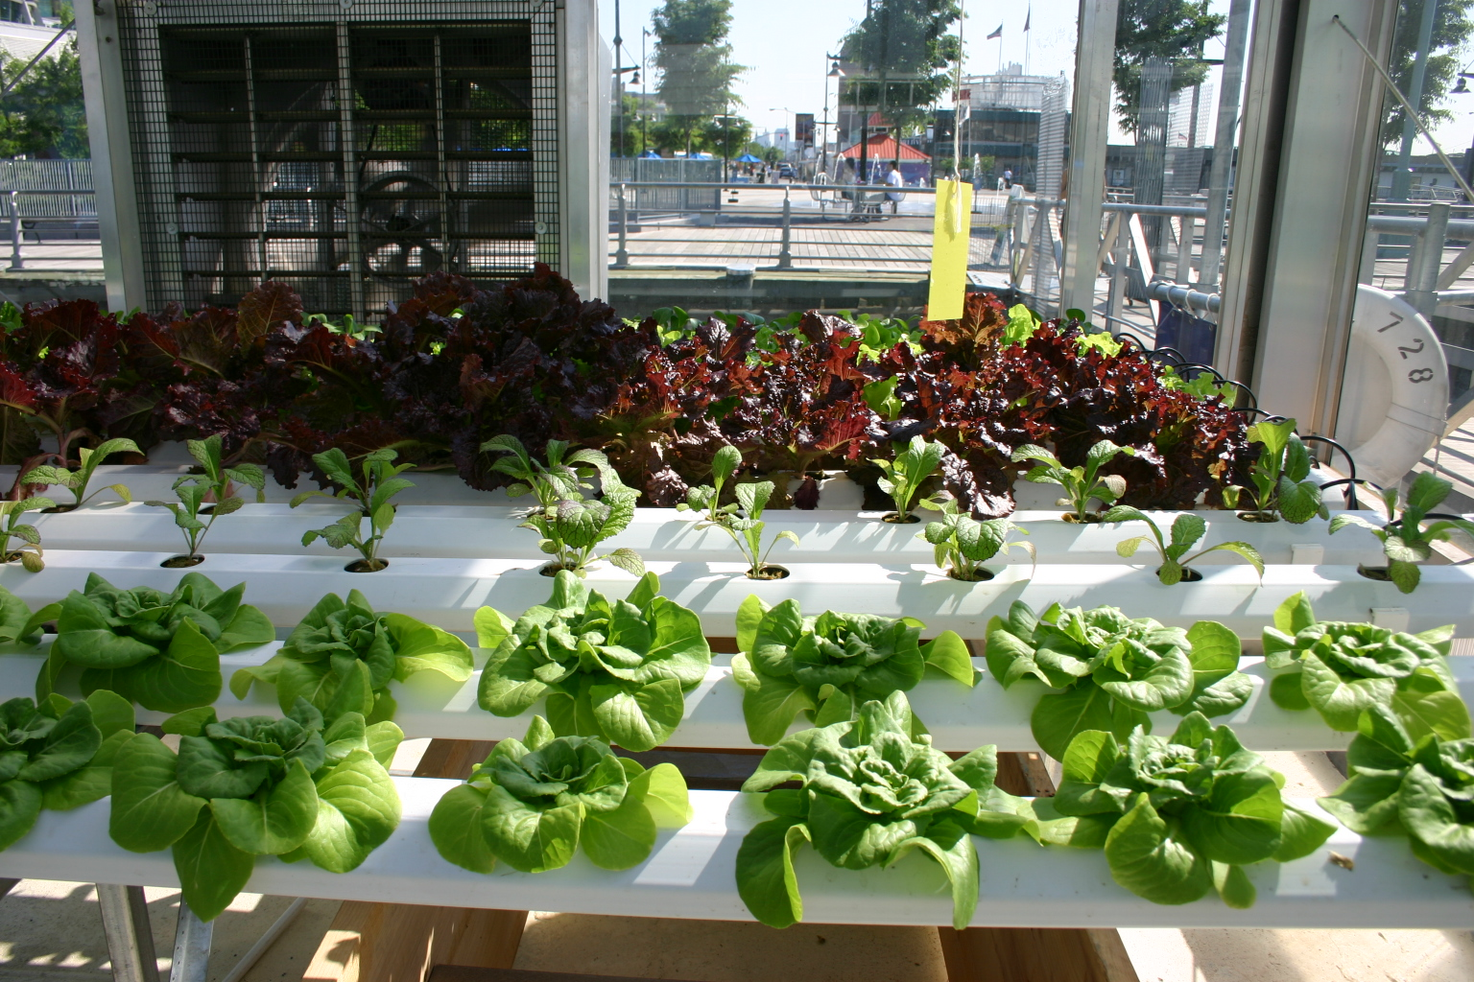
Source

Ohio’s climate falls in U.S. plant hardiness zones 5 and 6, which means your outdoor plants usually die after that first hard freeze. Have your children help bring your garden indoors for winter.

Another option? A hydroponic garden for growing herbs, small vegetables, and flowers. Hydroponic systems are available in various sizes -- you can place them anywhere in the house.

Kids will enjoy seeing fast-growing and aromatic leafy greens, tomatoes, peppers, and herbs ... they may even be eager to eat them!

Hands-on activity: Take a picture of the new growth every few days, print the photos, and then help your children create a growth calendar.

3. Day Trips and Fall Foliage
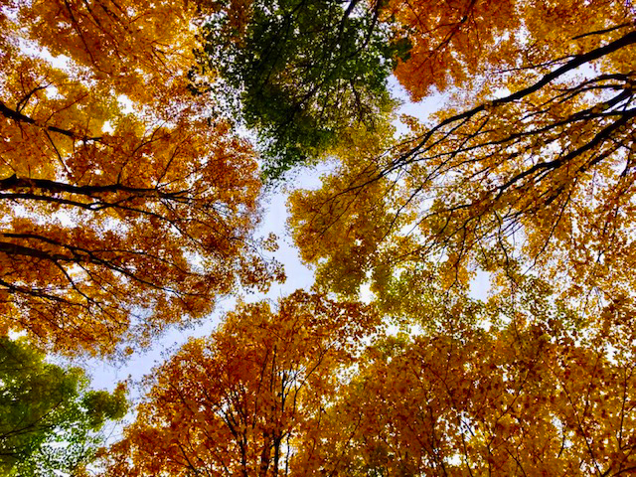
Source
Fall is the best time for driving through the countryside -- the scenery is breathtaking! Check out the freshly-plowed farmlands with rich brown soil ready for winter’s sleep. Stop at a pumpkin farm, pick apples, navigate a corn maze, and jump on a hayride. Visit wetlands and nature preserves around Lake Erie.
Enjoy the reds, yellows, and oranges and crisp fall lake air at Middle Bass and Kelleys Islands at the Lake Erie Islands. See how many native trees you and your children can identify.

Don’t forget about the six nature preserves on South Bass Island. Scheeff East Point Nature Preserve offers amazing views of Lake Erie and the surrounding Islands. It’s a bird lover’s paradise where you can also enjoy shoreline fishing. Massie Cliffside Preserve has a dock for fishing and a great trail for hiking.

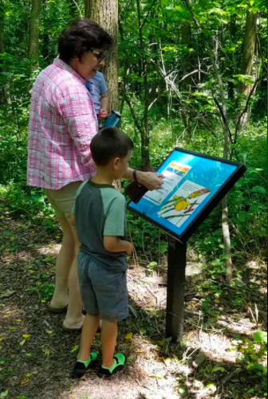
Children will love the Put-in-Bay StoryWalk. The trail has 17 storyboards posted along the path featuring pages from their favorite books.

They’ll be eager to move ahead on the trail to read the next page of Noisy Birds or The Curious Garden. They’ll also want to return again and again since the Erie Islands Library changes out the books every few weeks.

Source

When you return home, take a step back in time and show your children the joy of jumping into a pile of leaves. It’s a great way to motivate them to rake the yard.

Hands-on activity: Have your kids collect colorful, variously-shaped leaves such as those from maple and oak trees. Gather up acorns, seeds, twigs, pebbles, and pinecones. Bring along a bag for your child’s treasures. Better take an umbrella, too …

4. Treehouse
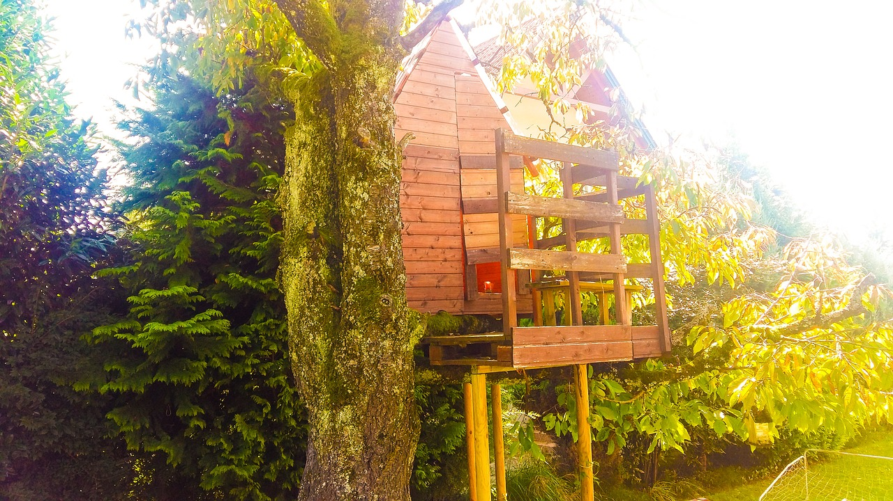
Source
Treehouses aren’t just for summer -- they’re fun to sit in all year long. Build a deck or house around a large canopy tree; the leaves may fall directly on you and the kids!
Treehouses are fun for adults, too. There may even be room up there for the family to enjoy some quality time together.
Hands-on activity: A treehouse can be a great place in fall to talk to your children about how plants get ready to survive in cold weather.

5. Build a Fire
Instead of logging onto a computer, teach your children the thrill of throwing a log onto the bonfire. Sitting around a campfire on a brisk, cool evening beats a night in front of the television or computer anytime.

Hands-on activity: Teach your children how to toast marshmallows. All you need are some long sticks, a bag of jumbo marshmallows, and maybe a few chocolate bars and graham crackers.

Savor the Season and Get Back to Nature
Autumn is the perfect time to enjoy nature with your little ones.
Take pictures of the visitors at the bird feeder, build a growth calendar featuring your indoor garden, jump in a pile of leaves, talk about trees in your treehouse, or share s’mores by the fire. Those are just a few examples. Be creative!
To beat cabin fever, you want to get as much fresh air and exercise before Ohio’s inclement weather sets in for the winter.
Andres Marten is a travel and landscape writer who lives in Ohio. He’s constantly on the move looking for the best places for exploring or living near nature’s finest.

