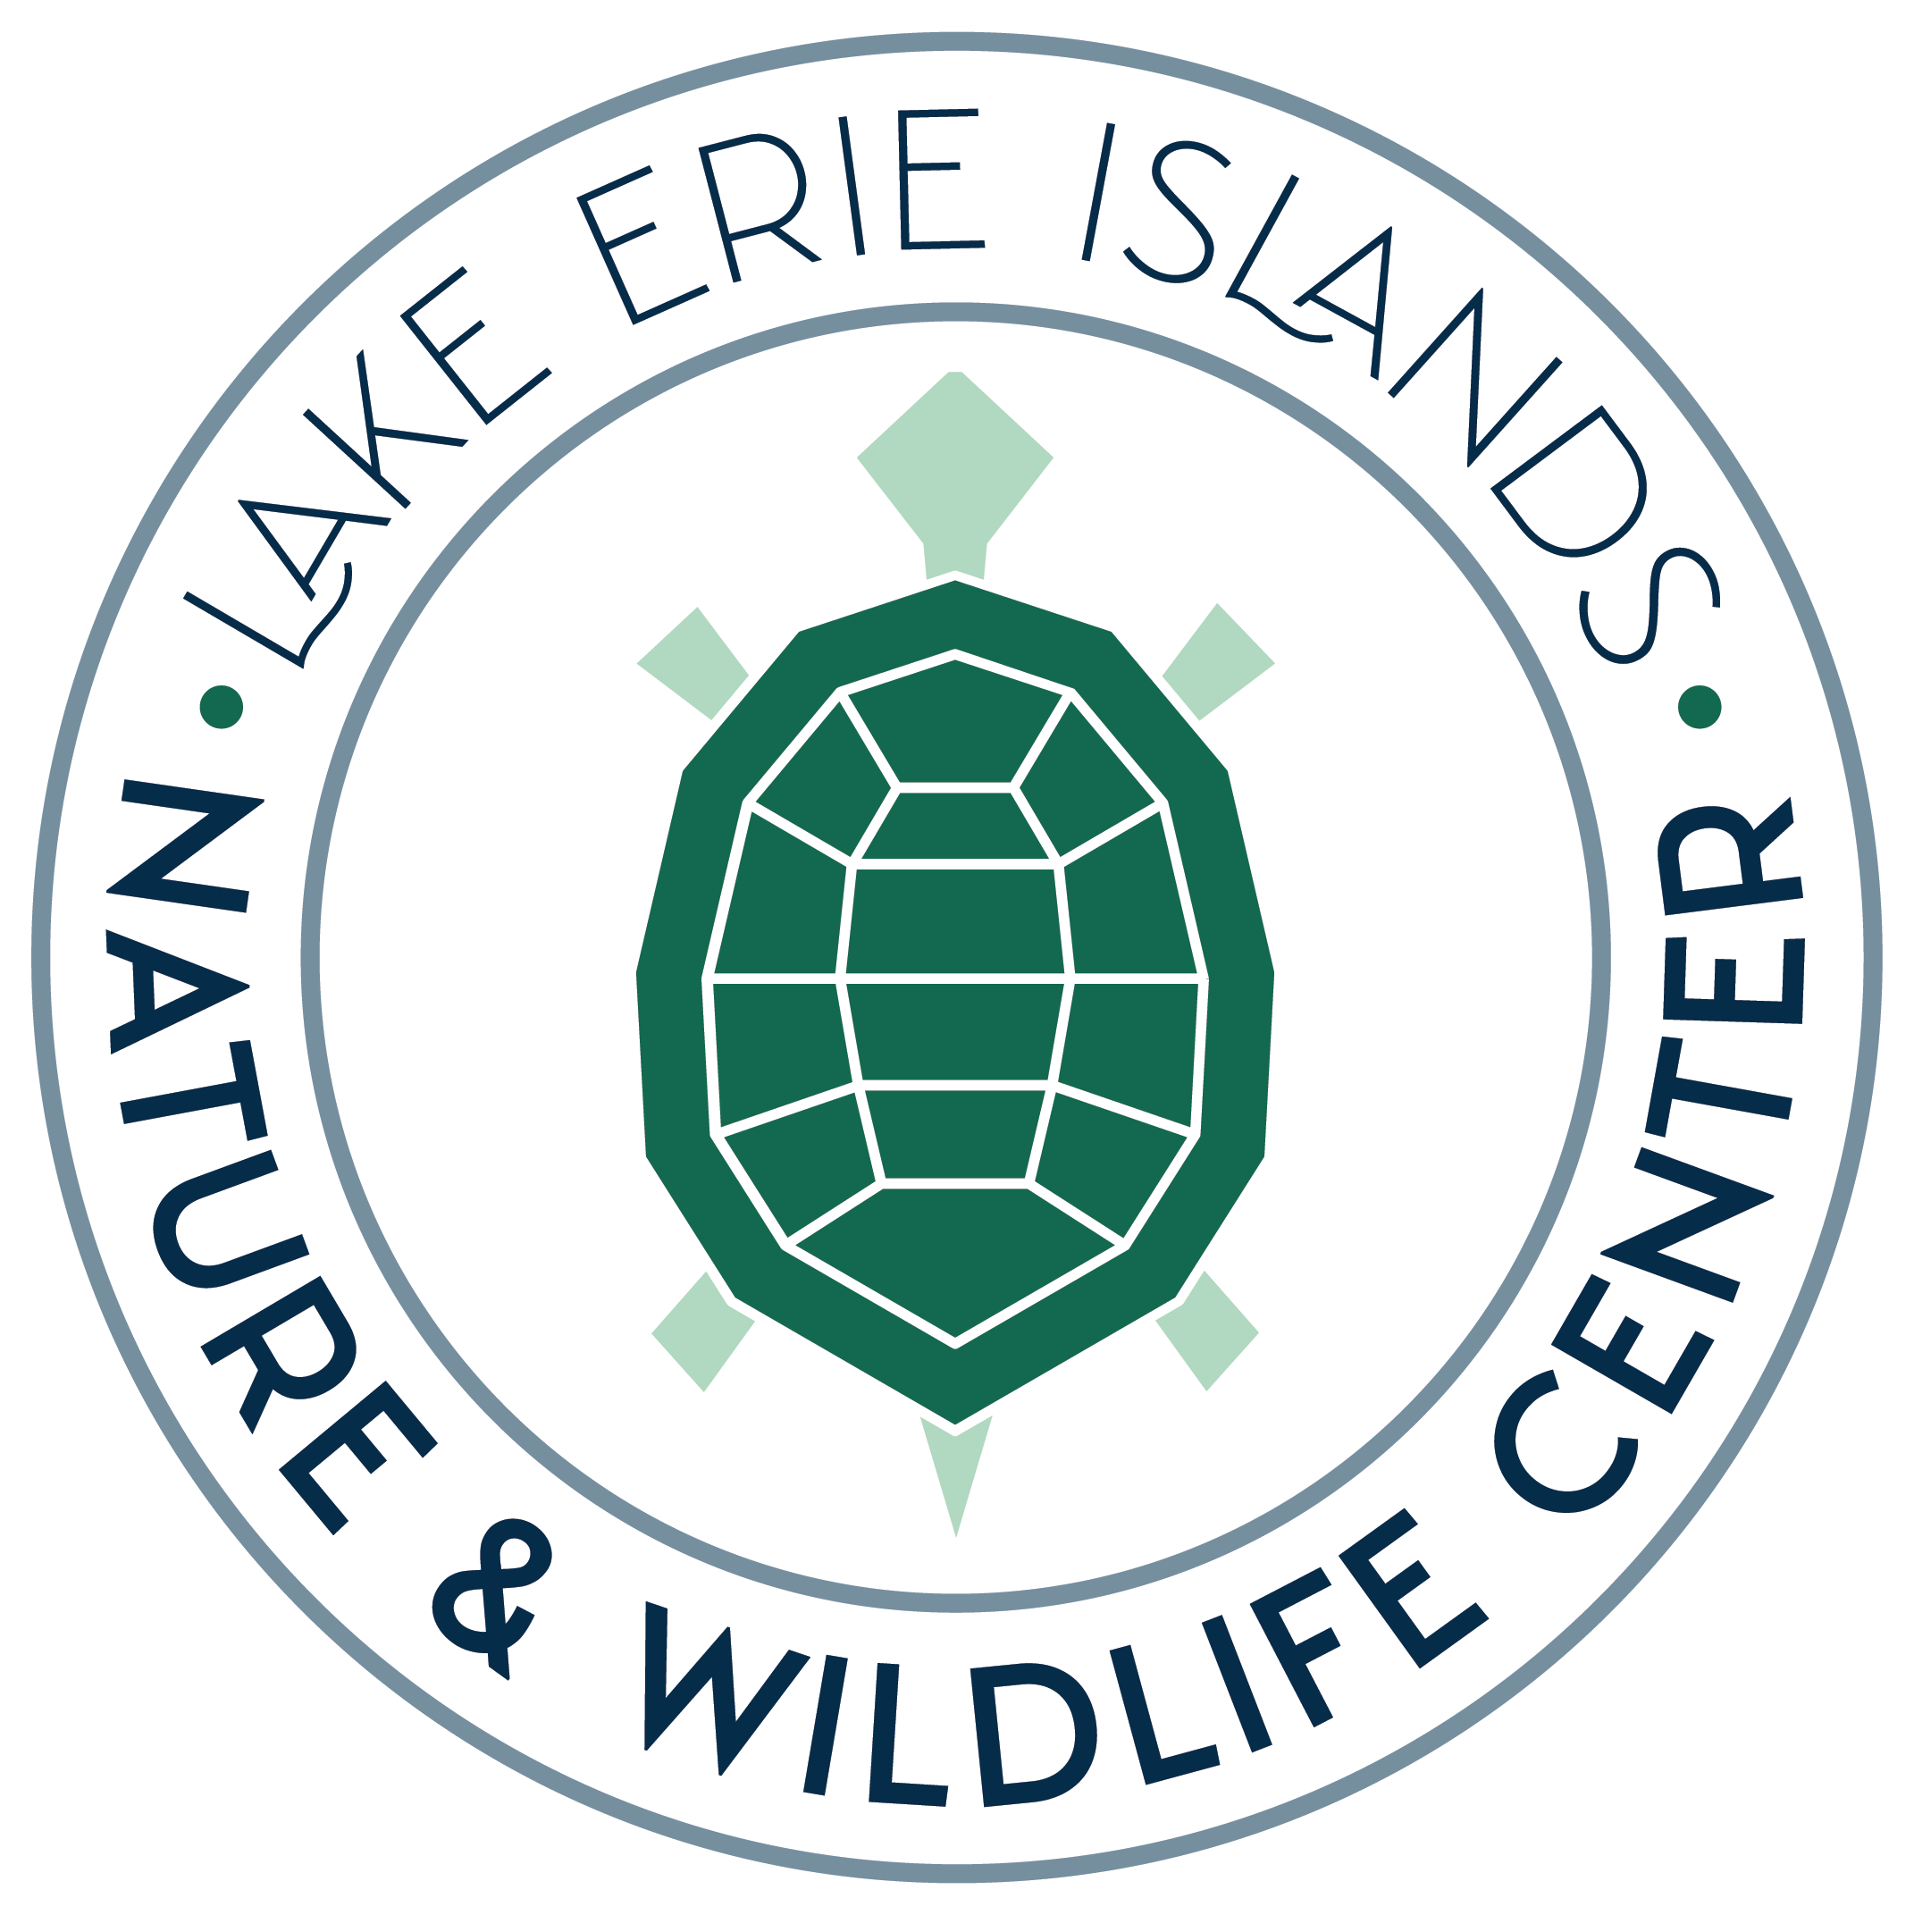
Put-in-Bay Nature Camp Registration 2024
PLEASE PRINT
Child’s Name Parent(s) Name(s)

Birth Date (Month/Day/Year – Must be of Age by Camp Date) 1st Time Camper?

Island Street Address During Camp

Home or Mailing Address

Island Phone Cell Phone

Email Address for Camp Communication

Emergency Contact Name & Number _______________________________________________________________________

(X) Camp Session Dates: Time: Price: Price After July 1:
___ Intro to Nature Camp (4yrs.)* July 8 - 12 11-12 AM $50 $55
___ My 1st Nature Camp (5-6yrs.)* July 8 - 12 12:30-1:30 PM $50 $55
___ My 1st Nature Camp (5-6yrs.)* 2:00-3:00 PM $50 $55
___ Nature Camp (7-8yrs.)* July 15 - 19 10-11:30 AM $55 $60
___ Nature Camp (7-8yrs.)* 12:30-2 PM $55 $60
___ Environmental Adventure Camp I (9-10yrs.)* July 15 - 19 2:30-4:30 PM $100 $105
CAMPOUT ON SOUTH BASS ISLAND
___ Environmental Adventure Camp II (11-14yrs.) July 22 - 26 TBA $110 $115
Maximum of 10 applications accepted. CAMPOUT ON NORTH BASS ISLAND
For Age 9 and older: Describe the child’s swimming ability ____________________________________________
****Maximum of 20 applications accepted in each session for ages 4-10
Registration Fee for Camp $ _____________
Donation to LEINWC PIB Nature Camp Fund + _____________
LEINWC Sponsorship (All levels include unlimited admission) + _____________
____ Black Squirrel - Individual ($20): No Camp Fee Discount
____ Monarch Butterfly - Family ($30): 5% Camp Fee Discount
____ Lake Erie Watersnake - Business ($100): 10% Camp Fee Discount
____ Bald Eagle - Life ($500): 25% Camp Fee Discount Sponsorship Discount - _______________
TOTAL ______________
Make checks to LEINWC. Mail to LEINWC Nature Camp Program, P. O. Box 871, PIB, OH 43456
*Confidential requests for scholarships for those expressing financial need can be made to leinwc@gmail.com*

You have my permission to use photos of my child participating in Nature Camp. (Please check those that you approve. Names will ONLY be used in
the Put-in-Bay Gazette.) NO NAME will be used with online photos of Nature Camp.

_____ Put-in-Bay Gazette ____ LEINWC Website ____LEINWC Social Media ____ LEINWC Newsletter

_______ Please send me information about Volunteer opportunities at the Nature & Wildlife Center (i.e. nature camp, events, etc.)

Permission Form
I fully understand that the nature of recreational and educational activities associated with Nature Camp includes an inherent risk of danger, which may result in personal injury or harm to my child. I grant permission for my child to participate in the program and activities of Nature Camp at the Bay, and I agree to indemnify and hold harmless the Lake Erie Islands Nature and Wildlife Center, its staff, directors, employees, Agents and/or representatives from any claim for any injury or damage which may result from my child’s attendance at and participation in the Nature Camp at the Bay. I authorize emergency medical treatment if none of the above-named emergency contact persons can be reached at the time of an emergency.

Signature of Parent/Guardian _________________________________Date_________________

